Proposal
for
UW Athletics



Submitted by:
Essentia Water
Beverly Shane

Dear UW Athletics,

Thank you for meeting with us this afternoon! Our company prides ourselves on improving people’s lives through better hydration because of our supercharged ionized water that rehydrates better.

In this booklet, we have put together all of the important information about Essentia Water you will need to move forward. We understand your athletes’ performance and health are two of your main concerns when moving forward with this deal and because of our super charged ionized water we know we will be a great fit for your teams! After discussing your needs, we have assessed that our solution will provide you with faster rehydration, a quicker recovery process, and most importantly, enhanced and optimized performance.

We are excited to move forward and hope to be apart of your department’s success. Again, thank you for your time and trust in our company.

Sincerely,

Essentia Water


Table of Contents

Customer Needs | 4
Areas of Concern | 5
Objectives | 6
Recommendations | 7
Addenda Table of Contents | 8

Customer Needs

- Faster rehydration
- Reasonable price point
- Optimized performance
  - We want your athletes to perform at their absolute best ability
- Quicker recovery time
  - Having a faster recovery time allows for a major competitive advantage
- Portable bottles
  - Water bottles will be easy to use and sturdy for athletes to take on the go at all times
- Eco-Friendly
  - All parts of bottles will be recyclable
    - Understanding that University of Washington plans to reach 70% waste diversion by 2020

Areas of Concern
- Pricing
  - We understand that you have a limited budget and you want to maximize your resources. On page 6 we will go into more depth about your pricing
  - options, including discounts on bulk orders

- Newness of Product
  - We understand that our product is fairly new on the market and not as well known as competitor brands, however the newness of our brand ensures our product is reliable and environmentally efficient with the recent change in sustainability standards.
- Need for Product
  - We understand that currently your athletes are hydrating with Powerade as well as Dasani water. Although you may think there is no need to switch to a different brand of hydration, we ensure you that the benefits of our water will be beyond beneficial for both the recovery and overall performance of your athletes. Our water will ensure a great competitive advantage for your athletes.

Objectives

Pricing
Through advanced purification and environmentally friendly packing material our production costs are a little more expensive, but it makes the quality of our product that much better. With this being said, we know your athletes will in turn perform equally as well

Newness of Product
Although Essentia is a fairly new brand of water compared to most standard bottled water brands, it has reshaped the hydration market and elevated the industry by introducing the most advanced and improved form of rehydration.

Need for Product
The water market has yet to encounter a pure alkaline water with an eco-friendly process like Essentia’s. With the bottled water market valued at $16 billion dollars, we know Essentia will create a high demand for people who are environmentally conscious, along with people looking to increase their athletic and everyday performance.

Recommendations

Pricing
We offer three different pricing options for bulk order, ALL include a discount. To maximize your team’s performance, we recommend ordering 150+ cases a month to ensure you have plenty of water for all of your athletes and to give you get the highest discount. Additionally, we offer just in time delivery, so you can save money and resources by not having to stock our product.

Newness of Product
Essentia is willing to provide a buy-back guarantee to help insure customer satisfaction and confidence in the purchase decision. In the off chance that you are unsatisfied with Essentia, we are willing to buy back your entire order with no questions asked.

Need for Product
Essentia is certain to create a competitive advantage for your athletes. By giving them a tool to rehydrate faster, their bodies will recover faster after workouts, and they will be able to improve more and more every day.

Addenda Table of Contents

Product Photos | 9
Hydration Study | 10
Promotional Ad | 11
Purchase Order Form | 12

Product Photos
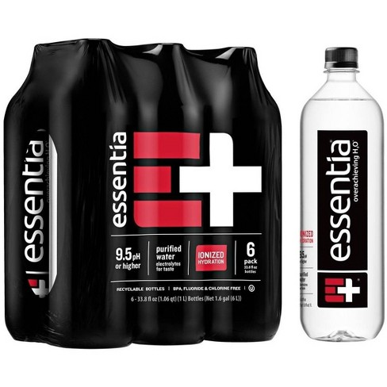

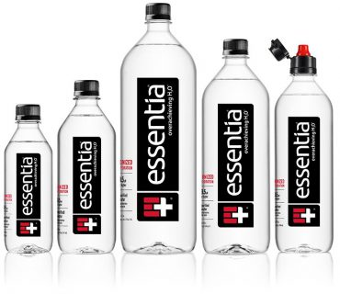

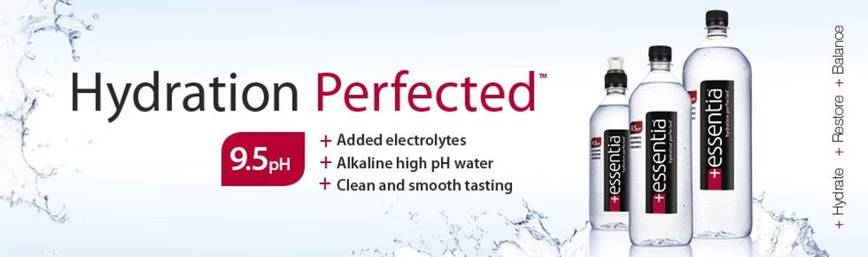

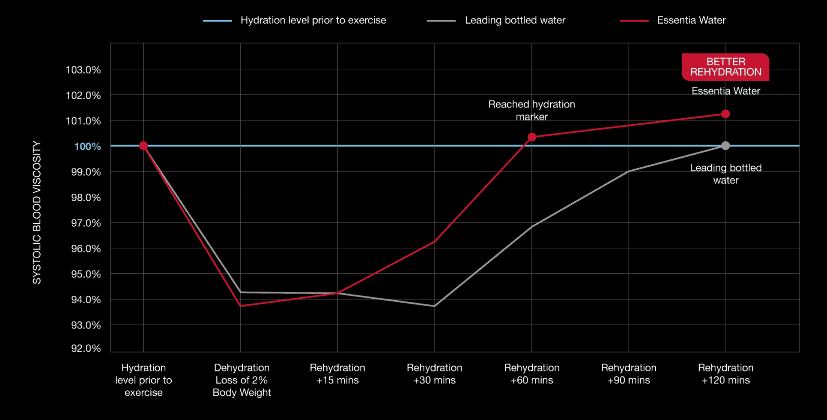

- This graph displays the Hydration Study Essentia conducted between our competitors and Essentia, in order to show the large difference in rehydration.
  - With equal prior hydration, Essentia hydrates better and faster than the competitor

Promotional Ad
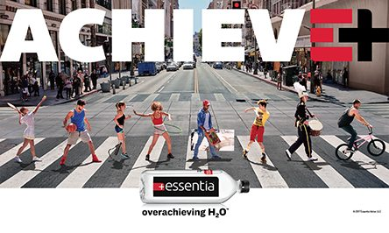

Purchase Order Form

Customer: University of Washington Athletic Department
Location: Seattle, WA
Item: Essentia Water Bottle Package

Suggested Order: 150 order of cases of Essentia water bottles

Recommended Purchase Cycle: 150+ units monthly

Buyer Signature__________________________________ Date_____________

Seller Signature__________________________________ Date______________

